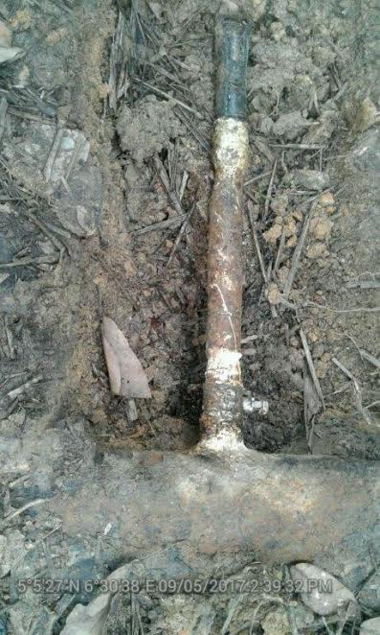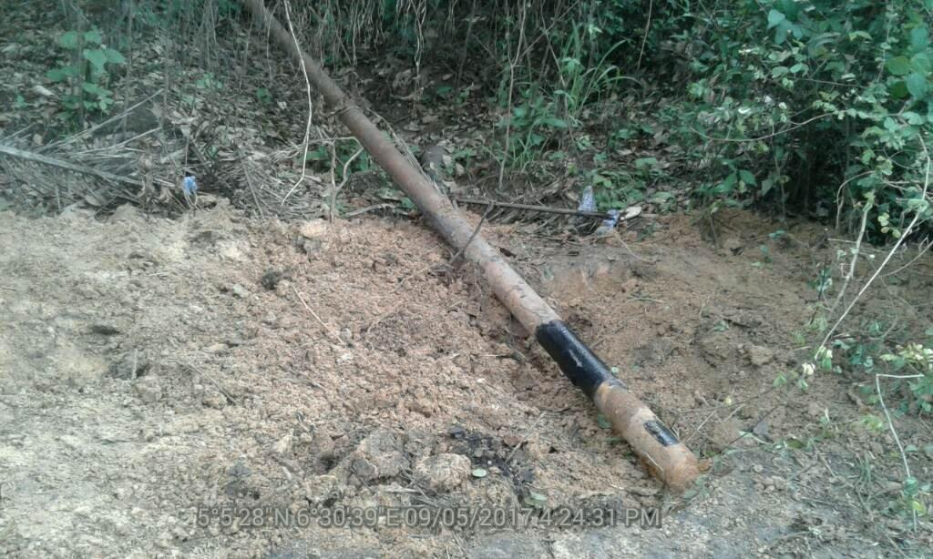
1.5” pipe was installed on the FL @3 O’clock Repaired point
position

